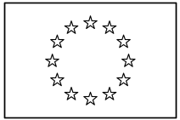 | EUROPEAN COMMISSION  DIRECTORATE-GENERAL  INFORMATICS  Information systems Directorate

European Commission
I&AM External Note #0022
EU Login Authentication Methods

24-Mar-2017
24-Mar-2017

Date: | 24/03/2017
Version: | 1.3
Authors: | Frédéric Poels
Reviewers: | Grégory DONY  -  -  -  -
Status: | To be approved

Introduction
EU Login aims at providing authentication services to systems of all European institutions and bodies. It authenticates users and hands over their identity to business applications. EU Login takes the role of identity provider because it provides identities to other systems. Business applications are service providers because they provide services to users. They are relying parties because they rely on EU Login for authenticating users. This allows service providers to obtain some degree of assurance about the identity of the user without having to manage passwords or other authentication elements.
Users authenticated by EU Login potentially gain access to all relying parties without having to re-authenticate, providing they used an authentication method that the service provider allows. This set up is referred to as single sign-on (SSO).
Over the years, EU Login has been extended to support a range of different authentication methods to fulfil the security and usability requirements of users and service providers. Each method has its own set of strengths and weaknesses that influences the probability that the identity provided by EU Login to relying parties matches the one of the actual person using the system.
There are two main reasons why an identity provider might serve erroneous identities to relying parties:
- At registration time, the identity on the service provider side might be linked to the wrong person (e.g. Anna creates an account and fools the system to appear as Bob). This risk is mitigated using identity proofing techniques that strengthen the registration process.
- At authentication time, the user might successfully claim an identity that was registered for someone else (e.g. Anna manages to use Bob's account). This risk is mitigated using authentication mechanisms that strengthen the authentication process.
Combining the strength of the registration process and the strength of the authentication process allows measuring the probability that an identity is genuine. The resulting value is known as the level of assurance (LoA).
This document describes the authentication methods offered by EU Login with their strengths and weaknesses and classifies them in a hierarchy of three levels of assurance: Basic, Medium and High.

Definitions and terminology

Authentication, identification and recognition
EU Login is an authentication service. Its purpose is to prove, with a certain probability, that the user is the legitimate owner of the account he is using and that the account represents its owner. The probability depends on the strength of the process used to prove ownership and on the strength of the process to create accounts.
EU Login is business agnostic. Identities are represented using an identifier that is generated in order to be unique. It is the responsibility of service providers to associate this identifier with a business identity by collecting business attributes. Once the association has been made, service providers have the assurance that a user coming with the same identity as the one used in the association is the same person. The strength of this assurance is set by the strength of authentication requested by the service provider. In other words, EU Login authenticates and recognises users while service providers identify them for doing business.
EU Login relies on two sources for creating accounts.

Provisioning
User accounts provisioned from Human Resource systems (e.g. for European Commission users) contain identities and attributes linked to the Human Resource business domain (e.g. personnel number, DG, directorate, unit, etc.). There is no need for service providers to collect these attributes via other means unless they require finer grained information available in COMREF. Identity checks are performed by Human Resource teams under their responsibility. The registration process involves providing official documents and is considered strong.

Self-service
Users can create accounts themselves using a self-service. No business attributes are collected since there is no way for EU Login to validate them. The registration process is considered weak but can be elevated under the responsibility of the service provider who can perform identity checks.

Prompting for authentication credentials
Authentication can only happen on the EU Login server itself. A service provider requiring user authentication must redirect the user to EU Login where the full authentication process takes place. No third-party is involved. In particular, the user interacts directly with the EU Login server that prompts him to provide his authentication credentials. The service provider does not handle authentication credentials in any way. Only the EU Login server is allowed to obtain and validate them. It does not expose and will never expose interfaces to validate authentication credentials collected anywhere else. This guarantees that the way credentials are collected and the nature of credentials being collected can change without impacting service providers. It also simplifies inspecting that credentials are properly handled (i.e. not leaked or logged) since only the EU Login server needs to be monitored.
Communications between the user and EU Login are always encrypted. Authentication credentials entered on the EU Login web site are never sent unencrypted over the wire even if the service provider does not implement SSL/TLS.

Storing authentication credentials
Authentication credentials are stored in the private EU Login repository in hashed format. This prevents administrators and attackers from gaining access to credentials in clear text.

Opt-in
An information system that requires a certain level of security must accept all authentication strengths that are at that level or above. However, some authentication strengths could be considered optional and would have to be accepted in opt-in mode using explicit configuration.

Authentication factors
An authentication factor is a category of credential used for authenticating that is subject to specific vectors of attack. There are three main authentication factors:
- Knowledge factor is vulnerable to obtaining something the user knows (e.g. phishing): password, PIN code, etc.
- Possession factor is vulnerable to obtaining something the user has (e.g. stealing): ID card, token, etc.
- Inherence factor is vulnerable to replicating something the user is (e.g. impersonating): fingerprint, iris scan, etc.
Authentication can rely on one factor or on multiple ones. Adding factors increases security because it makes it harder for an attacker to obtain all credentials needed to use an account (e.g. combining the knowledge factor and the possession factor requires an attacker to phish a secret and steal an item). Authentication using one factor is called single-factor authentication. Authentication with two or more factors is called multi-factor authentication.
Combining credentials from the same factor can increase security to a much lesser extent because the set of credentials is still subject to a single vector of attack. Authentication using two credentials from the same factor is called two-step authentication.

Management of authentication factors
A user who is able to authenticate using two factors can only manage second factors using self-service after having successfully authenticated using two factors.
Service providers that require two-factor authentication receive an extended user identity that contains an identifier and a version number. They are encouraged to link access rights to that pair of attributes rather than to the sole identifier.
A user who was able to authenticate using two factors and who becomes suddenly unable to do so because he lost access to second factors (e.g. stolen or compromised) can use a specific process to immediately unlink all second factors from his account ("panic" button). As a side effect, the version number is increased and the user loses all access rights to applications that link authorisation to the extended user identity comprising both the identifier and the version number. This process guarantees that a discontinuity in the strength of the link between the user and his account (e.g. unlinking something the user possesses and linking something an attacker possesses) does not endanger applications that require two-factor authentication.

ECAS Mobile App
The ECAS Mobile App is an application that can be used on mobile devices (Android, iOS and Windows Phone) in order to improve the user experience when browsing on the mobile device itself or in order to provide additional authentication methods.
All users have access to a self-service that allows them to pair an installed ECAS Mobile App with their account. It requires first authenticating on a desktop computer or other device. The ECAS Mobile App is managed as a second factor and all rules described in section 2.6 apply. The following steps are involved:
- After successfully authenticating on a desktop computer, the user is prompted with a challenge represented using a QR code.
- The user scans the QR code with the ECAS app and is prompted to select a PIN code that will be used to secure the ECAS Mobile App.
- The ECAS Mobile App sends the PIN code to the EU Login server.
- The EU Login server stores the PIN code and sends a push notification to the mobile device in order to ensure that the user is holding it. The push notification is sent using standard notification services from the mobile device operating system (Google, Apple or Microsoft).
- The ECAS Mobile App notifies the EU Login server that the push notification was received.
- The EU Login server generates a secret that will be used to authenticate the user and shares it with the ECAS Mobile App.
- The ECAS Mobile App stores the secret.

Authentication methods
EU Login provides 12 different authentication methods. Each one has its own set of strengths and weaknesses in terms of both security and user experience. The ECAS client configuration file refers to them with the following names:
- PASSWORD;
- NTLM;
- PASSWORD_SMS;
- PASSWORD_SOFTWARE_TOKEN;
- PASSWORD_MOBILE_APP;
- MOBILE_APP;
- PASSWORD_TOKEN;
- PASSWORD_TOKEN_CRAM;
- MDM_CERT;
- CLIENT_CERT;
- STORK;
- SOCIAL_NETWORKS.
This section describes each method and provides elements to evaluate their strength.

PASSWORD
Username & Password
The PASSWORD authentication method is based on username and password. The following steps are involved:
- The user identifies the account he wants to use by means of a username and demonstrates that he is the legitimate owner by means of a secret password (knowledge factor).
- Authentication is successful if the provided elements are valid.

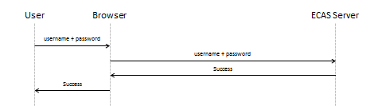
Passwords policies, such as expiration and complexity, are dynamically configurable by an ECAS administrator and apply to a whole domain corresponding to a given user population (e.g. European Commission users). In particular, policies cannot be set per application or per user.

NTLM
Single Sign-On with Windows
The NTLM authentication method allows users who are authenticated on a Windows machine in the NET1 domain to be transparently authenticated in EU Login without having to explicitly provide credentials. Eligibility to use NTLM authentication is based on the IP address of the user's machine that has to belong to a defined range.

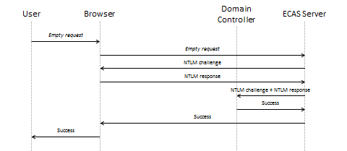

There is a tight coupling between the Windows password and the EU Login password since initialising and resetting the EU Login password relies on accessing the user's mailbox using the Windows password. The NTLM authentication method can be seen as functional alternative to the PASSWORD authentication method for European Commission users. It adds an additional surface of attack via the NTLM protocol but it mitigates risks of phishing. In order to control the load on Domain Controllers, system owners have to explicitly request the activation of the NTLM authentication method for their application. Activation happens at the EU Login server level on an application per application basis.

PASSWORD_SMS
Username & Password + OTP via SMS
The PASSWORD_SMS authentication method is based on username, password and a one-time-password sent to the user's mobile phone using Short Message Service (SMS). The following steps are involved:
- The user identifies the account he wants to use by means of a username and demonstrates that he is the legitimate owner by means of a secret password (knowledge factor).
- At the same time, the user provides a mobile phone number where the one-time-password will be sent.
- If the password is valid and if the mobile phone number is registered within the user account then the EU Login server sends a short text message containing a one-time-password.
- The user provides the one-time-password in order to demonstrate the he holds the mobile phone (possession factor) and has access to it (possibly knowledge or inherence factor if access to the mobile phone is protected using a secret or biometrics).
- Authentication is successful if the one-time-password is valid.

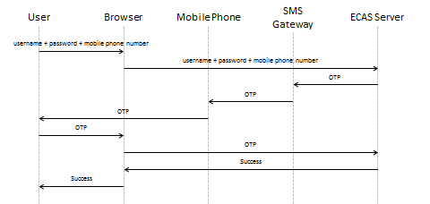

Registering a mobile phone number for using the PASSWORD_SMS strength follows a different process depending on the type of user.

Mobile phone registration for European Commission users
European Commission users register their mobile phone number in Sysper2 and give their consent to provide the information to EU Login for authentication purposes. The mobile phone number is then provisioned in the EU Login repository. When the user changes his mobile phone number in Sysper2, the modification is automatically replicated in EU Login.
The rules described in 2.6 do not apply.

Mobile phone registration for users of other European institutions and bodies
Accounts for users of other European institutions and bodies are created on the basis of data provided during the standard provisioning process when new members of the personnel take up duties. The data contains all user attributes including the mobile phone number. The process used for setting and changing mobile phone numbers is not managed inside EU Login and is under the full responsibility of the European institution or body. Modifications of user data, including changes of mobile phone numbers, are provisioned to EU Login on a daily basis.
The rules described in 2.6 do not apply.

Mobile phone registration for self-registered users
Self-registered users have access to a self-service that allows them to manage their mobile phone numbers.
When adding a mobile phone number to their account for the first time, a one-time-password is sent to the provided number allowing the user to demonstrate that he is in possession of the device.
All rules described in section 2.6 apply.

PASSWORD_SOFTWARE_TOKEN
Username & Password + OTP via Software Token
The PASSWORD_SOFTWARE_TOKEN authentication method is based on username, password and a one-time-password generated by the ECAS Mobile App installed on a mobile device. The following steps are involved:
- The user identifies the account he wants to use by means of a username and demonstrates that he is the legitimate owner by means of a secret password (knowledge factor).
- If the password is valid, the user is prompted with a challenge represented using a QR code.
- The user scans the QR code with the ECAS Mobile App that generates a one-time-password based on the secret shared at registration time. It allows the user to demonstrate that he holds the mobile device (possession factor).
- Authentication is successful if the one-time-password is valid.
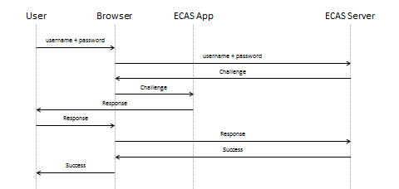

PASSWORD_MOBILE_APP
Username & Password + PIN Code + Acknowledge Push Notification
The PASSWORD_MOBILE_APP authentication method is based on username, password and a challenge/response exchange between the EU Login server and the ECAS Mobile App installed on a mobile device. The following steps are involved:
- The user identifies the account he wants to use by means of a username and demonstrates that he is the legitimate owner by means of a secret password (knowledge factor).
- The EU Login server sends a message with a challenge to the ECAS Mobile App using standard notification services from the mobile device operating system (Google, Apple or Microsoft).
- The user acknowledges the push notification, which launches the ECAS Mobile App that prompts the user for his PIN code.
- The user enters the PIN code. The ECAS Mobile App initiates an HTTPS connection with the EU Login server where it provides the user identifier, the PIN code and the challenge in order to demonstrate that it was received and that the user is therefore holding the device (possession factor).
- Authentication is successful if the provided elements are valid.

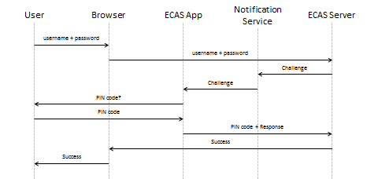

MOBILE_APP
PIN Code + Acknowledge Push Notification
The MOBILE_APP authentication method targets users accessing resources on a mobile device. It is based on a PIN code and a challenge/response exchange between the EU Login server and the ECAS Mobile App installed on the mobile device. The following steps are involved:
- The user selects "On-Mobile" authentication on the EU Login sign-in screen, which launches the ECAS Mobile App. The ECAS Mobile App prompts the user for his PIN code.
- The user enters the PIN code. The ECAS Mobile App initiates an HTTPS connection with the EU Login server where it provides the user identifier and the PIN code.
- If the PIN code is valid (knowledge factor), the EU Login server sends a message with a transaction identifier and a challenge to the ECAS Mobile app using standard notification services from the mobile device operating system (Google, Apple or Microsoft).
- The user acknowledges the push notification. The ECAS Mobile App computes a response to the challenge using the secret shared at registration time. It redirects the user to the EU Login web site with the transaction identifier and the response in order to demonstrate that the challenge was received and that the user is therefore holding the device (possession factor). The transaction identifier allows the EU Login server to correlate the challenge that was sent with the response being received.
- Authentication is successful if the provided elements are valid.

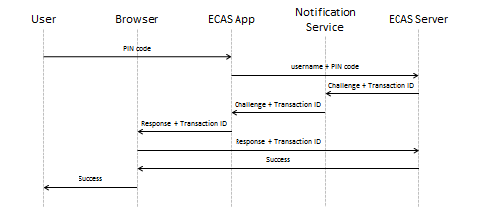

PASSWORD_TOKEN
Username & Password + OTP via EC Hardware Token
The PASSWORD_TOKEN authentication method is based on username, password and a one-time-password generated by a corporate VASCO hardware token. The following steps are involved:
- The user identifies the account he wants to use by means of a username and demonstrates that he is the legitimate owner by means of a secret password (knowledge factor).
- At the same time, the user provides the identifier of his hardware token and generates the one-time-password allowing him to demonstrate that he holds the token (possession factor).
- If the password is valid and if the token identifier is registered within the user account then the one-time-password is validated against the corporate VASCO Identikey server. Authentication is successful if the one-time-password is valid.

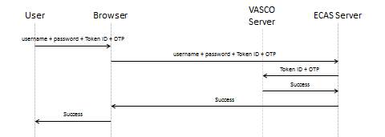

The user is prompted to provide his EU Login password even though the token is protected with a PIN code. This guarantees that a single attack (e.g. obtaining the token private key or gaining control on the corporate VASCO Identikey server) cannot compromise both the knowledge factor and the possession factor. Corporate VASCO hardware tokens are programmed by the vendor who generates key pairs and stores private keys in the token. There is a risk that the vendor might leak private keys to attackers (e.g. the alleged hacking of Gemalto).
Linking a corporate VASCO token with a user is part of the process of distributing tokens. It is managed outside EU Login and is therefore outside the scope of this document. EU Login does not provide a self-service for managing corporate VASCO tokens. All rules described in section 2.6 apply in the sense that a user who has a corporate VASCO token must authenticate using it in order to register another second factor. The link between corporate VASCO tokens and users is established as part of standard provisioning procedures by the ITIC helpdesk when a user orders a token. The link is stored in the EU Login repository and it is the responsibility of EU Login to validate the link when the user authenticates.

PASSWORD_TOKEN_CRAM
Username & Password + Challenge/Response via DG CLIMA Hardware Token
The PASSWORD_TOKEN_CRAM authentication method targets users accessing DG CLIMA resources, such as the Union Registry for Emissions Trading. It is based on username, password and a response to a challenge generated by a DG CLIMA VASCO hardware token. The following steps are involved:
- The user identifies the account he wants to use by means of a username and demonstrates that he is the legitimate owner by means of a secret password (knowledge factor). At the same time, the user provides the identifier of his hardware token.
- If the password is valid and if the token is registered in the user account, ECAS contacts the DG CLIMA VASCO Identikey server, which generates a challenge for the given token. The challenge is presented to the user.
- The user enters the challenge into the token and generates the one-time-password allowing him to demonstrate that he holds the token (possession factor).
- The one-time-password is validated against the DG CLIMA VASCO Identikey server. Authentication is successful if the one-time-password is valid.

The user is prompted to provide his EU Login password even though the token is protected with a PIN code. This guarantees that a single attack (e.g. gaining control on the DG CLIMA VASCO Identikey server) cannot compromise both the knowledge factor and the possession factor. DG CLIMA VASCO hardware tokens are programmed by DG CLIMA who generates key pairs and stores private keys in the token. The vendor cannot have access to private keys.
Linking a DG CLIMA VASCO token with a user is part of the process of distributing tokens. It is managed outside EU Login and is therefore outside the scope of this document. EU Login does not provide a self-service for managing DG CLIMA VASCO tokens. All rules described in section 2.6 apply in the sense that a user who has a DG CLIMA VASCO token must authenticate using it in order to register another second factor. The link between DG CLIMA VASCO tokens and users is provisioned in the EU Login repository. It is validated both by EU Login and by the DG CLIMA VASCO Identikey server when the user authenticates.

MDM_CERT
Single Sign-On with MobileIron
The MDM_CERT strength targets users accessing resources on a mobile device from within a MobileIron secure container. It allows users who have authenticated against the corporate MobileIron Sentry server to be transparently authenticated in EU Login without having to explicitly provide credentials. The following steps are involved:
- The user authenticates against the corporate MobileIron Sentry server and tries to access a resource that requires EU Login authentication. He is redirected to the EU Login server.
- Communication between the user and the EU Login server go through the MobileIron Sentry server that acts as a reverse proxy. It adds an HTTP header containing the user's identity.
- The EU Login server ensures the connection originates from the IP address of the MobileIron Sentry server and extracts the HTTP header to retrieve the user's identity.
- The EU Login server invokes a SOAP web service provided by the MobileIron Sentry server to ensure the identity corresponds to an active session.
- If all conditions are fulfilled, the EU Login server trusts the identity provided by the MobileIron Sentry server and authentication is successful.

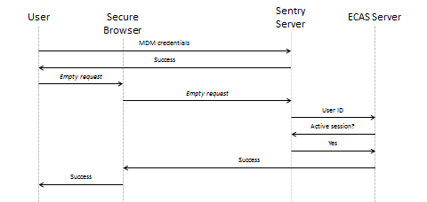

CLIENT_CERT
The CLIENT_CERT authentication method targets systems accessing resources requiring EU Login authentication. It is typically used by monitoring processes that have to authenticate in order to reach an information system they need to probe. It is neither convenient nor secure for automated processes to parse login screens and post credentials such as username and password. The following steps are involved:
- The system asks for the EU Login sign-in screen. The EU Login server detects that the client is a system rather than a user on the basis of its IP address and redirects it to the CLIENT_CERT authentication URL that requires a two-way SSL/TLS connection.
- The system initiates a two-way SSL/TLS connection with the EU Login server that obtains the system identity from the SSL/TLS layer. Authentication is successful.

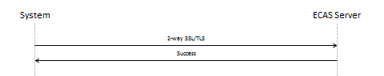

It is not necessary for the system to first try to access the service provider and be redirected to EU Login for being authenticated. As an optimisation, the system can go straight to EU Login. Similarly, the first step described above can be skipped since its outcome is predictable. However it allows the flow to be closer to the one that users are experiencing.
The CLIENT_CERT strength is only accessible to accounts that are flagged for being used by systems. Several elements allow distinguishing these accounts including the format of the identifier and an attribute indicating the type. This lets service providers adapt their behaviour and limit privileges for monitoring processes.

STORK
National eID
The STORK authentication method allows users who authenticate nationally with their eID to be transparently authenticated in EU Login. The legal basis for mutual recognition of eID in Europe is known as eIDAS and was adopted in 2014. It applies to all Member States and to the European Union that has a special status allowing it to be recognised as a consumer of identities but not as a provider of identities. The implementing acts were published in September 2015. Member states have to go through a notification process followed by a publication in the official journal before they can operate in production mode. The STORK authentication method is expected to remain experimental until at least January 2018.
Authentication using an eID is Member State specific and can rely on various means, such as chip cards, mobile devices, biometrics, etc. Once the identity of the user is obtained nationally, it is propagated to the EU Login server using identity federation mechanisms that rely on the SAMLv2 Web Browser Single Sign-On profile with HTTP POST Binding. Trust is established using digital signature (XMLDSig) without involving a Certification Authority. eIDAS foresees that authentication methods used nationally are classified according to their strength. However, EU Login will treat all national authentication methods at the same level as long as the STORK authentication method remains experimental.
The STORK authentication method has high political value and is being closely monitored by the European Commission and by the European Parliament. Governance is managed by the eIDAS Committee (legal) and by the eIDAS Cooperation Network (operational). DIGIT is involved in both via CEF (Connecting Europe Facility). eIDAS and the STORK authentication method are of utmost importance to CEF Digital Service Infrastructures, eSENS (Electronic Simple European Networked Services) and UUM&DS (Uniform User Management and Digital Signature).

SOCIAL_NETWORKS
Facebook, Twitter, Google
The SOCIAL_NETWORKS authentication method allows users who authenticate on social networks to be transparently authenticated in EU Login. The OAuth protocol is used between the EU Login server and social networks.
Authentication via social networks involves registering on the social network and authenticating using the social network policy. Security-wise, it is very similar to the self-registration process in EU Login that relies on an e-mail address. Obtaining the e-mail address involves registering at the e-mail provider level and authenticating using the e-mail provider policy. Instead of having to explicitly register in EU Login by creating an account, users authenticating via social networks are implicitly registered thanks to the automatic creation of an account happening behind the scene.
The SOCIAL_NETWORKS authentication method can be seen as functional alternative to the PASSWORD authentication method for self-registered users. However, it adds an additional surface of attack via the OAuth protocol. In particular, version 2.0 of OAuth is known to have security limitations by not supporting signature, encryption, channel binding and client verification inside the protocol. These features are delegated to the transport layer (SSL/TLS). In order to prevent from exposing applications to unexpected risks, system owners have to explicitly request the activation of the SOCIAL_NETWORKS authentication method for their application. Activation happens at the EU Login server level on an application per application basis.

Authentication methods classification
EU Login supports 3 levels of assurance:
- Basic;
- Medium;
- High.
A service provider that accepts a level allows all authentication mechanisms in it and automatically accepts all levels above.
The table below summarises the characteristics of the 3 levels.
Level | Authentication Methods | Registration & Management
Basic | PASSWORD  NTLM*  STORK  SOCIAL_NETWORKS* | Self-service requiring the Basic level or above
Medium | PASSWORD_SMS  PASSWORD_SOFTWARE_TOKEN  PASSWORD_MOBILE_APP  MOBILE_APP  MDM_CERT | Self-service requiring the highest available level
High | PASSWORD_TOKEN  PASSWORD_TOKEN_CRAM  CLIENT_CERT | No self-service
* Activation required

Basic
The basic level offers authentication methods based on a single factor or equivalent. These methods provide a friendly user experience involving a single device. However, they are vulnerable to a single vector of attack of moderate complexity.
Self-service facilities are provided for registering and managing credentials when applicable. Users are normally able to recover lost credentials by themselves.
The basic level is suitable for information systems that do not have high security requirements, ranging from public applications that require personalisation to closed user group applications that do not hold sensitive business or private data.
After a proper evaluation, the basic level could suit the needs of information systems with a confidentiality level ranging from PUBLIC to LIMITED BASIC and an integrity level up to MODERATE.

Medium
The medium level offers authentication methods between two-step and multi-factor. These methods take the user experience into account while involving multiple devices or tools. They are vulnerable to a single vector of attack of high complexity or combined vectors of attack of moderate complexity.
Self-service facilities are provided for registering and managing credentials under conditions. Users are normally able to recover lost credentials by themselves at the expense of losing access rights that they will have to recover for each service provider.
The medium level is suitable for information systems with significant security requirements including closed user group applications holding moderately sensitive business or private data.
After a proper evaluation, the medium level could suit the needs of information systems with a confidentiality level ranging from PUBLIC to LIMITED BASIC and an integrity level ranging from MODERATE to CRITICAL.

High
The high level offers authentication methods based on multiple factors. These methods put the focus on security at the expense of the user experience. They involve multiple devices. They are vulnerable to combined vectors of attack of high complexity.
Self-service facilities are not provided for registering and managing credentials. A helpdesk must be involved in all cases.
The high level is suitable for information systems with high security requirements including closed user group applications holding sensitive business or private data.
After a proper evaluation, the high level could suit the needs of information systems with a confidentiality level ranging from PUBLIC to LIMITED HIGH and an integrity level ranging from MODERATE to CRITICAL.
It must be noted that EU Login authentication is not suitable for systems handling EU Classified information or for strategic systems.

